Town of Clifton Park Zoning Board of Appeals
One Town Hall Plaza
Clifton Park, New York 12065
(518) 371-6054
FAX (518) 371-1136
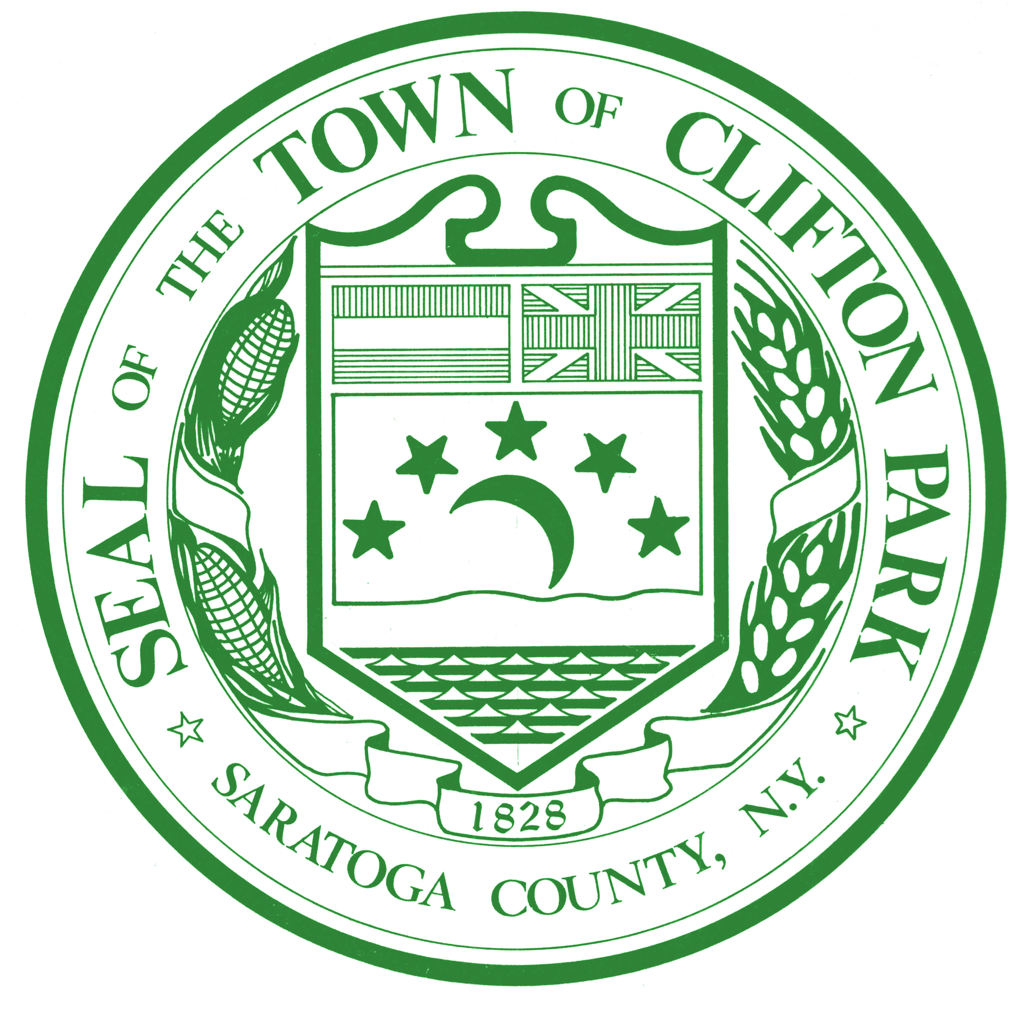

Zoning Board of Appeals
July 6, 2026

Present: Chairman Michael Dudick, Christopher Lemire, John Klimes, Lisa McCoy, Juliano Febo, Mark Brockbank, Gerald Schuth (alternate)
Absent: Scott Styles
Also Present: Scott Reese, Building and Zoning Paula Cooper, Secretary Kevin Luibrand, Attorney
The meeting was called to order at 7:00 p.m.
All stood for the Pledge of Allegiance. Roll call was taken.
Mr. Dudick stated in the absence of Mr. Styles, Mr. Schuth would be a voting member tonight.

Mr. Dudick told the applicant that per Town Code that the applicant would need 4 out of 7 of the Board members to vote in favor of the application to pass. He let the applicant know that there are 7 voting members of the Board here tonight, so that 4 of the 7 members need to vote in favor tonight to grant the variances. He asked the applicant if they would like to come back at a later date or if they would like to proceed knowing the Board tonight needs to vote in favor of the application with at least 4 votes.
The applicants stated they would like to continue tonight knowing 4 of the 7 votes need to be in favor of the application tonight.

Old Business:
None

New Business:
An application from Matthew Signs LLC requests the following area variances:
- Town Code Chapter 171 - Signs, Attachment 2, Chart I - Commercial. Based on the formula A = 0.005 X GFA, a 2,650-sq-ft building is permitted 13 sq. ft. of wall-sign area. However, the ordinance any wall sign to a minimum of 32 sq. ft. The proposal includes five wall signs, totaling of 108 sq. ft. The applicant therefore seeks an area variance of 76 sq. ft. to allow the proposed signage.
- Town Code Chapter 171 - Signs, Attachment 2, Chart I (Permitted Signs - Commercial), which limits each tenant to two wall signs. The proposal includes five wall signs for this applicant. The applicant seeks an area variance to permit three additional wall signs.
- Town Code Chapter 171- Signs, Attachment 2, Chart I - Commercial. The maximum height of a freestanding sign is 18 feet. The proposal shows the freestanding sign at 25- feet. The applicant seeks an area variance of a 7-feet relief of the 18-feet maximum height for a freestanding sign.
- Town Code Chapter 171- Signs, Attachment 2, Chart I - Commercial. The maximum height of a wall sign is 20 feet. The proposal shows the wall signs at 22-feet. The applicant seeks an area variance of a 2-feet relief of the 20-feet maximum height for a wall sign.
The property is located at 811 NY Route 146, Clifton Park, NY.
Applicant:
Matthew Kusewich stated he is here tonight foe the application. He stated the variances are for a standard rebuild for the Taco Bell. He stated that the building faces 3 roads, Route 146, Old Route 146 and Clifton Country Road. Mr. Kusewich state they would like to brand all 4 sides of the building and showed the elevations with the proposed signs. He stated that the free standing sign is being proposed for 25’ to go where the existing on is along Route 146.
Public:
No public comment.
Mr. Dudick moved, second by Mr. Lemire to close the public hearing at 7:28 p.m.
Board:
Ms. McCoy asked if trees have been removed for this project. Mr. Kusewich stated he believes some of them have been but he is unsure of which.
Mr. Dudick stated the trees may be blocking the sign and asked why the applicant wants a higher sign. Mr. Kusewich stated the applicant wants a better visual for the sign as the building sits below Route 146. Mr. Dudick asked how many signs did the business have before it was torn down Mr. Kusewich stated he is unsure.
Mr. Reese stated that the proposed freestanding sign is not going to be in the same location as the current one. Mr. Reese showed the old building and the signs.
Mr. Lemire stated that he estimates the applicant having 2 signs since it is a corner lot. Mr. Brockbank agrees with the comment made.
Ms. McCoy stated that everyone in the area knows where the Taco Bell is in Town.
Mr. Febo asked if the drive thru would have branding. Mr. Kusewich stated it would not.
Mr. Dudick asked why the applicant is taking down a building to replace it. Mr. Kusewich stated he is not positive but he believes it is cheaper to take it down and rebuild.
Mr. Lemire asked if there is another business going there as well. Mr. Reese stated that a 7Brew will be there as well and he believes the placement of the new Taco Bell building will allow for better flow through the site.
Ms. McCoy asked where they are showing the wall signs. Mr. Reese showed the renderings and stated max for the signs height is 22’ and they are asking for 25’ for all 4 elevations.
Mr. Dudick asked if the tenant on the property had already asked for more signs in the past.
Mr. Febo asked if this is a different zone than Chick-fil-a. Mr. Reese stated Chick-fil-a is in the TC5 zone and this is on the TC6.
Mr. Schuth asked what the height of the sign across the road was. Mr. Reese stated the mall has its own sign permit and showed on the screen all the signs for Market 32, the mall, Chick-fil-a and Taco Bell.
Mr. Brockbank stated that Chick-fil-a has 2 signs and the old Taco Bell has 2 as well. He asked why they want more now. Mr. Kusewich stated they want more advertising.
Mr. Dudick at the corner is higher than where the original freestanding sign is. He stated that this is a longstanding business and it always has customer so he does not understand why they need more signage. Mr. Kusewich stated they are looking to brand the front, parking lot, and rear and they will get rid of the sign by the drive thru.
Mr. Lemire asked what the size of the signs was. Mr. Kusewich stated 108 sf. Mr. Lemire asked which 2 would need to be kept if others had to go. Mr. Kusewich stated the front door or the drive thru sign.
Mr. Reese stated this is an Unlisted action pursuant to SEQRA. He stated the Saratoga County Planning Board heard the application on 6/22/26 and they found no community impact. Mr. Reese stated Public Notice went out on 6/30/26 and mailings went out on 6/26/26 with no public comments.
Ms. McCoy asked the applicant if he would be willing to minimize the request. Mr. Kusewich stated he would want one on the rear facing wall along Old Route 146 and one additional wall sign.
Mr. Lemire Mr. Lemire stated that if you go into the rear then you are on the site and where you need to be as a customer. He stated that they have a freestanding sign so why do they need a sign on Route 146.
Mr. Reese stated that 3 wall signs were given to McDonalds and this is the only variance he is aware of.
Mr. Dudick stated he has no problem with request part “d” as it looks like architecture however; he is not in favor of the others they are asking for.
Ms. McCoy stated that she feels if “a” is eliminated or decreased it would change the variance from 76 sf to 5 sf and have 2 signs but larger.
Mr. Reese stated that the applicant can do this but asking for 2 signs and then come back for 3 would be too similar of an ask if he is denied tonight the 5 requested. If he is denied the applicant can come back after one year. Mr. Febo stated he can always come back and ask for more.
Mr. Lemire stated the applicant can table the application and go back to his client to see what they are willing to do as well.
Mr. Dudick moved, second by Mr. Febo to reopen the public hearing for this application.
Mr. Kusewich stated he would like to table his application for tonight and reschedule it for a later date.
Mr. Dudick stated the applicant has 62 days to come back to the Board.

New Business:
An application from Gilbert VanGuilder Land Surveyor, PLLC requests an area variance from Chapter 208-11 of the Clifton Park Town Code. The minimum land area per dwelling unit for a parcel in the R-3 district without central water or sewer is 100,000 square feet. The proposed lot area is 64,618 square feet. The variance requested is a reduction of 35,382 square feet from the 100,000-square-foot minimum lot size. The property is located at 203 Vischer Ferry Road, Clifton Park, NY.
Applicant:
Pat Jarosz stated he is here tonight representing the applicant for a subdivision of his property just south of the transfer station so his son can build a home. Mr. Jarosz stated the land has a historic building on it in the rear and the applicant would like to keep that building on his property to ensure it remains.
Public:
No public comments.
Mr. Dudick moved, second by Mr. Febo to close the public hearing at 8:07 p.m.
Board:
Mr. Brockbank asked why the lot he is creating be larger. Mr. Jarosz stated the applicant wants to keep the historical structures on his property and not lose control over them. He stated that there is a natural break in the land there as well. Mr. Jarosz stated there are two home across the road that have smaller lots as well so they would be staying within the character of the neighborhood.
Mr. Lemire asked what the size of the current lot is now. Mr. Jarosz stated it is 10.7 acres of land. Mr. Lemire asked to see the proposed lot lines and then asked if they could adjust the lines to make lot 2 larger and keep the historical structures on the applicants parcel. John Gagnon, owner and applicant, stated he built the current home on 10 acres and he doesn’t want property to get cut up so he would like to keep it rectangular and to be able to keep a yard around it. He stated the main home is centered on the property.
Ms. McCoy asked if the applicant has a concern that the historical buildings would be demolished. Mr. Jarosz stated that they want to maintain control of them as they date back to the Civil War Era.
Mr. Febo asked when the parcels across the road were established. Mr. Reese stated he does not have that record off hand. Mr. Febo stated that this does seem to be in character and this property seems to look better than the established on. Mr. Jarosz stated there is land that belongs to Clifton Park around this lot.
Mr. Brockbank asked, if the lot were to have water and sewer, what the minimum requirement is. Mr. Reese stated that the minimum size with water and sewer is 80,000 sf.
Mr. Lemire asked if the applicant could put in deed restrictions for the historical buildings. Mr. Febo stated if it is deed restricted it decreases the value.
Mr. Dudick asked if the applicant could add land to the rear but not include the structures. Mr. Gagnon stated his son wants symmetry and the rear would be useless property. Mr. Febo stated this can create useless land and affect value.
Mr. Lemire asked what the 100,000 sf is needed for as a requirement. Mr. Klimes stated there needs to be room on the land for a leech field. Mr. Jarosz stated that the tow properties across the street also have septic and well.
Mr. Reese stated this is an Unlisted action pursuant to SEQRA, the Saratoga County Planning Board stated there was no community impact, Public Notice was given on 6/30/26, and mailings were sent out on 6/8/26 with no inquiries or comments.
Mr. Febo stated that the 100,000 sf requirement was made 40 years and and maybe longer, so in this case this is an established lot that can be built on and there are others that are similar in the area. He stated he does not feel puzzle piecing is necessary.
Mr. Dudick stated the applicant and the Board need to look at what the minimal reasonable request can be.
Mr. Lemire asked if the applicant could move the lot line further south. Mr. Gagnon stated he would rather not. Mr. Lemire stated that if the new owner is the son then this can just be a line on a map. Mr. Gagnon stated that when the land goes to someone else it may not be looked at the same and he would like to preserve it while he can now.
Mr. Dudick stated that even with water and sewer, this would still be small. Mr. Reese stated it still would be.
Mr. Febo asked how this lot would be any different than the other two lots that predate code. Mr. Dudick stated that they are different because they predate code. Mr. Gagnon stated that he has owned the property for about 20 years. Mr. Dudick sated he would like the applicant to get to a least 80,000 sf.
Mr. Lemire stated there are 10 acres on this property so there is plenty of space to get to 100,000 sf. Mr. Dudick stated that applicant wants to stay with strait lines and it is hard to grant variances based on vegetation growth. Mr. Dudick asked if relief from Code is a desire or a necessity.
Mr. Schuth asked if the applicant is unwilling to move the lot line to the south. Mr. Gagnon stated he does not want to; he wants to give 1.57 acres to his son.
Mr. Jarosz stated he would like to table the application tonight and discuss what can be done with the applicant.
Mr. Dudick stated it can be tabled and the applicant has 62 days to come back to the Board for a decision.

New Business:
An application from Terry Burks requests an area variance from Town Code Chapter 171- Signs, Attachment 4, Chart III - Residential. freestanding signs for houses of worship are required to maintain a minimum setback of 15 feet from the front property line. The proposed sign location is a zero (0) foot setback from the front property line. The variance requested is a relief of 15 feet from the front property line. The property is located at 713 Clifton Park Center Road, Clifton Park, NY.
Applicant:
Terry Burks stated he is on the Board for the church located at 713 Clifton Park Center Road and he works with the finance. He stated the church wants to update their sign and did not understand why the current sign did not meet code. He stated they hope to update the sign that is currently in place since it is an electrical sign with a stone foundation. Mr. Burks stated they would like the white portion turned into a digital sign and they would like to make it smaller, from 72.5”x30” to 66”x28”
Public:
No public comments.
Mr. Dudick moved, second by Mr. Febo to close the public hearing at 8:44 p.m.
Board:
Mr. Brockbank stated this does make sense as it is a preexisting sign.
Mr. Dudick asked how long the sign has been there. Mr. Reese stated it has been there since 2002.
Mr. Lemire asked if the sign is updated, do they still need a variance. Mr. Reese stated they do.
Mr. Reese stated this is an Unlisted action pursuant to SEQRA, the Saratoga County Planning Board stated there was no review necessary, Public Notice was given on 6/30/26, and mailings were sent out on 6/26/26 with no inquiries or comments.
Mr. Dudick stated he has been by the church and it is established, the speed limit there is 30 mph and wildlife is now used to the signage so he does not see a problem with the application.

Mr. Brockbank moved, second by Mr. Klimes, to approve the variance as requested. The property is located at 713 Clifton Park Center Road, Clifton Park, NY.
Mr. Brockbank read the Variance Criteria, Mr. Brockbank answered in favor to all 5 criteria.
The Secretary called the Vote:
Ayes: Dudick, Brockbank, Febo, Klimes, Lemire, McCoy, Schuth
Noes: None

New Business:
An application from Terry Burks requests a use variance from Town Code Chapter 171-4 H.(3)(n), as animated signs are prohibited on the subject parcel, which is not located within any of the zoning districts or designated areas where such signs are permitted. The property is located at 713 Clifton Park Center Road, Clifton Park, NY.
Applicant:
Mr. Burks stated that the owner is looking for a new assign as the current one is not safe. He stated that changing the lettering is dangerous and they cannot do it at all in the winter. He stated they have not yet had any injuries but it can create them. Mr. Burks stated with the lack of advertising it is hard to get the message out to the community. Mr. Burks stated he understands there is no flashing allowed but they still want to reach out to the community and this needs updating.
Public:
No public comments.
Mr. Dudick moved, second by Mr. Klimes to close the public hearing at 9:01 p.m.
Board:
Mr. Dudick stated that there are different criteria for this site as it is a place of worship as well as criteria for signs.
Mr. Dudick stated that the Town has animated signs required to be back 100’ to allow for slower speeds.
Mr. Brockbank stated that the most convincing statement for him to consider this is the safety risk.
Mr. Lemire stated there are different elements to variances when they are places of worship. He asked where this is stated in Town Code. Mr. Burks stated they would only light up the sign from 8 a.m. to 8 p.m. and the current restriction is 6-11p.m. Mr. Reese read from digital sign restrictions put forth by the Town and listed the requirements.
Mr. Dudick read from the use variance criteria and stated it is hard to look at this as a use and it is also a house of worship. Mr. Dudick stated the Town needs a sign ordinance.
Mr. Reese stated this is an Unlisted action pursuant to SEQRA, the Saratoga County Planning Board stated there was no review necessary, Public Notice was given on 6/30/26, and mailings were sent out on 6/26/26 with no inquiries or comments.
Mr. Febo asked why this is considered a variance. Mr. Reese stated because the sign is outside the allowable area or zone. Mr. Reese pulled up minutes from a previously approved variance from St. Edward’s Church from 2019.

Mr. Dudick moved, second by Mr. Schuth, to approve the variance as requested. The property is located at 713 Clifton Park Center Road, Clifton Park, NY.
Mr. Dudick read the Variance Criteria, Mr. Dudick answered that not all criteria are applicable here due to churches being exempt.
The Secretary called the Vote:
Conditions:
- The sign shall only be on from 8 a.m. to 8 p.m.
- The owner must follow all other restrictions for digital signs
Ayes: Dudick, Brockbank, Febo, Klimes, McCoy, Schuth
Noes: Lemire

The chairman made a motion to approve the minutes from the June 15, 2026 meeting. All who were present at the June 15, 2026 meeting voted in favor and the meeting minutes were approved.

Mr. Dudick, Chairman, made a motion to adjourn the meeting, Mr. Febo second, all voted in favor and approval was unanimous. The meeting was adjourned at 9:14 p.m.

The next scheduled ZBA meeting will be held on August 3, 2026.

Respectfully submitted,
Paula Cooper
Paula Cooper
Secretary, Zoning Board of Appeals

